**Figure 1: Theoretical Frameworks**

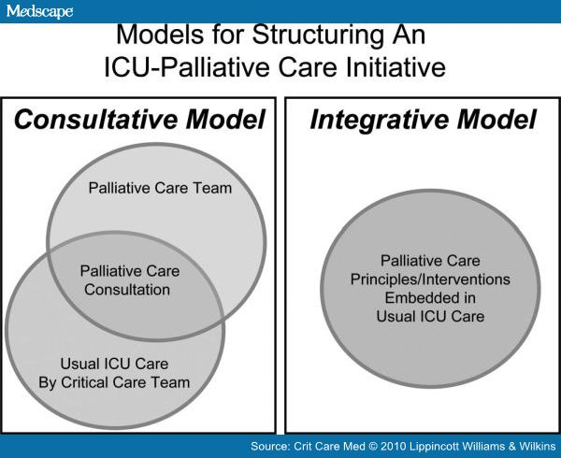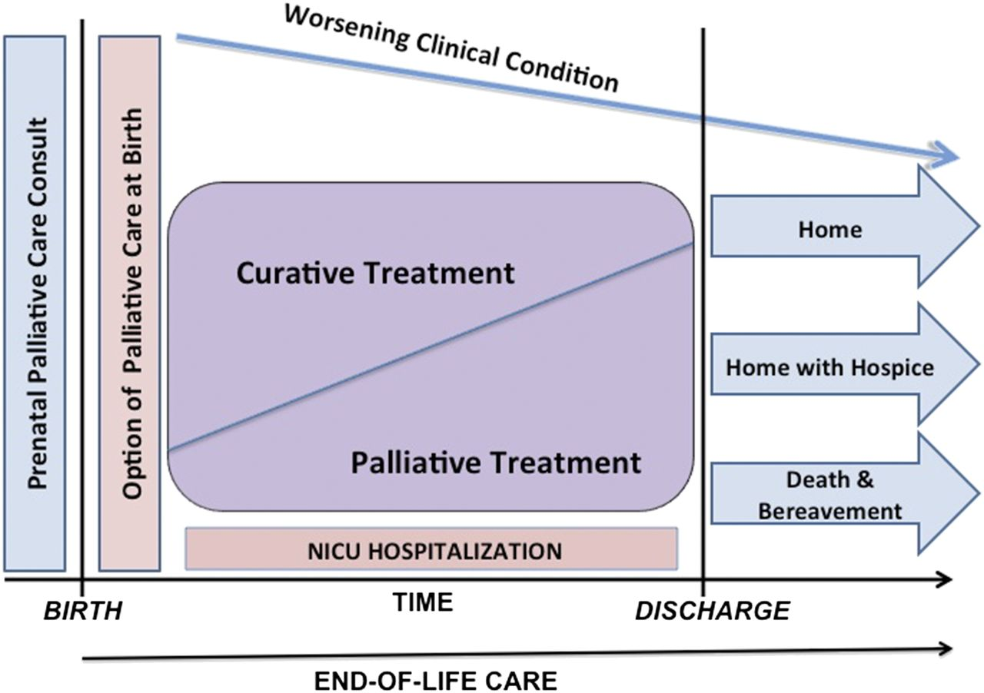**Integrative Model for Palliative Care for Infants Models for Structuring AN ICU-Palliative Care Initiative**